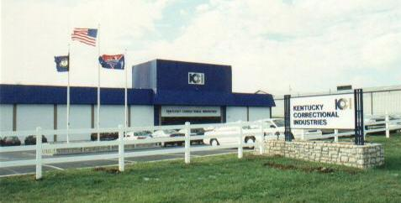
Visit the showroom located at 1041 Leestown Road Frankfort, KY

Kentucky Correctional Industries (KCI) is a state agency and there is a statutory requirement to give KCI first preference when buying products manufactured by them. Please refer to letter from Mike Burnside, Director of Division of Material and Procurement Services dated May 15, 2002 reminding all state agencies of 45A.470. This letter was forwarded to all procurement officers for their review and use. Call (502) 564-4510 if you have any questions regarding the letter.

Kentucky Correctional Industries will be opening a new facility in July 2002 to manufacture trashcan liners. Twenty-nine additional janitorial items will be distributed by KCI including mops, stick mops, brooms, brushes, handles, dust mops, and buckets & wringers. These new products will supplement their CorrectPac and Golden Rod line of cleaners.

Kentucky Correctional Industries manufactures and distributes: wood furniture, office seating, modular office furniture, janitorial products, clothing, lockers & shelving, mattresses, institutional furniture & signage. KCI services include: refinishing & reupholstery, embroidery, data imaging & entry, printing, graphic arts, and recycling.

Kentucky Correctional Industries is a self-supportive division of the KY Department of Corrections under the Justice Cabinet. KCI receives no appropriated tax monies and generates all operating funds and expansion capital out of KCI profits. KCI incurs all the normal operating expenses, such as utilities, salaries, equipment replacement, etc. that any private sector company would incur.

Kentucky Correctional Industries mission is to utilize inmate labor to produce and perform services that are a fiscal benefit to the Commonwealth. We provide a realistic work experience and marketable skills that improve our inmates’ chances for securing gainful employment upon their release. Utilizing structured employment practices and approved training programs, KCI provides a broad range of products and services to state, county, and city government agencies.

